2019
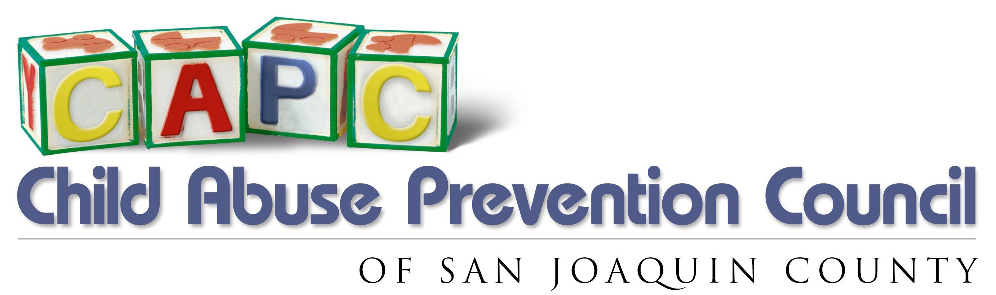

MEMBERSHIP FORM
AUXILIARY

You are invited and encouraged to attend our meetings and participate in our projects. Donations are gratefully accepted and always welcome. Volunteer opportunities too!

Name
Spouse

Address

City/Zip

Mobile Work _ Home

Email Newsletter __ US Mail __ Email__
Birthday(s)

ANNUAL MEMBERSHIP DUES

New Membership Renewal Membership Gift Donation

□   Individual/Family Membership - Active ($40)
□ Contributing Membership – ($50)     □ Gifted Donation ($ )

I would like to contribute to promote awareness of child abuse prevention, in the following areas:
□ Volunteer at Center | □ Ducky Derby | □ Adopt-A-Family  □ Fundraising
□ Fashion Show  □ Luncheon & Socials | □ Classroom Support  □ Auxiliary Board | □ Fundraising  □

Membership Includes Membership Amount $
- Newsletters
- Awesome Event Invites I’d like to make an additional gift of $
- Volunteer Opportunities
- Pride in bringing awareness Total amount enclosed $
& prevention of child abuse!

Return payment to:
Child Abuse Prevention Council Auxiliary
CAPCA
Attn: Membership Chair, Danielle Call
P.O. Box 1257
Stockton, CA 95267

Checks payable to CAPCA
$5 of each paid membership to be donated to The Child Abuse Prevention Council.
Thank you for all your interest, dedication and support in the prevention of child abuse!

For any questions or concerns, please contact Danielle Call – 209.598.2503 or Daniellecapca@gmail.com

